Design for Poultry Sales Management

**Syed Naqvi**

**P2652259**

*May 18, 2021*

Table of Contents

**Abstract** 1

Introduction 1

Literature review 2

Methodology 2

Interface design: 2

Data Storage: 6

Program Function: 7

Testing: 10

Conclusion: 10

# **Abstract**

In the era of modernization in poultry, it is important to have sales management to ensure the quality service to its customers and owners. This will reduce the hectic labor intense work. While reducing the cost of work without reducing the quality of work. This coursework discusses the importance of innovation in poultry using computer and software technology. It elaborates the system using methodology, class diagram, ER diagram, and wireframes. Which will further discuss the importance of managing sales in poultry using software technology.

# Introduction

The utilization of programming computer programs is carried out generally in the improvement of domesticated businesses. Most manufacturers are moving towards modernization through mechanized programming.

Active improvement is making each business defeat the need for high work and sources. Thus, Poultry entrepreneurs should carry out a satisfactory efficient technique to keep up their trades, oversee stock, break down contracts, and guarantee customer delight. Exciting work diminished a great deal because of their adequate deal overseeing programming. It can improve consumer loyalty. Various causes have motivated this modernization in business that helps to adopt mechanical strategies and demonstrable skill. A modernized deals the board framework is made to deal with all the essential data needed to figure benefits and misfortunes. A different data set is kept up to deal with every one of the costs of that business. Plan for Poultry Sales Management means to have an exact technique for overseeing and planning with the traffic. It will help the poultry organizations to build selling goals. It will help centre around singular buyer requests and the market point of view. This undertaking means to present more ease of use in various exercises, for example, record upkeep and looking. Keeping in track with the deals has never been this easier by having the deal's ID, date, and shopper's name. The information is put away in the data set, confining ordinary clients in recovering data, which just approved clients can have advantages to get to.

# Literature review

This application was arranged because of the absence of modernization in the field of poultry farming. In this period, any business needs to have appropriate deals with management programming. The absence of legitimate programming made this system conceivable. Virtual products like effiasoft, integreater, feedsoft and most applications out there require costly participation. The vast majority of this product don't give appropriate assessment over worker's assignment and the buying power. Our product has choices to store the information of the trader, work that was given to the representative on that day, legitimate deals the executives with an appropriate buys data set. Despite the fact that product like effiasoft is costly to keep up. We handled it by giving a practical sales management board framework.

# Methodology

We selected the waterfall model for this undertaking. Necessities were obvious all along. The waterfall model doesn't need explicit preparation for the undertaking. Little tasks will in general have an objective and it's difficult to get demotivated. It maintains the concentration until the point isn't cleared. If Contrasted with different procedures this model is best for little ventures, it is more obvious, and simpler to oversee.

# Interface design:

Login:

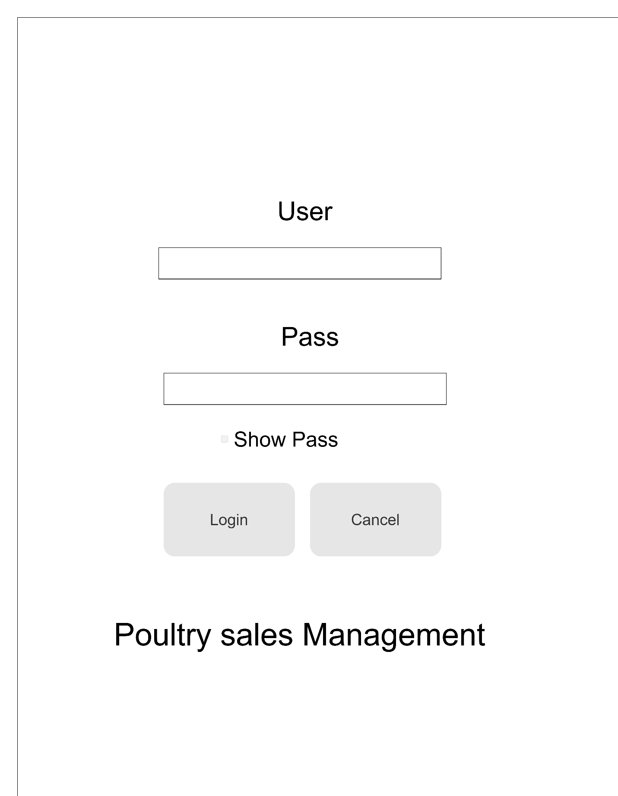

This application will begin with the Login structure. The worker needs to sign in to the application to continue their use with the application. It has the choice to enter the User and Password that Admin has made for them through registering.

Registration:

This structure is confined to administrator only. It requires the administrator's password to get to the records. It can save the username, password, name and age of the worker. The administrator can insert another record or can erase an old record that existed.

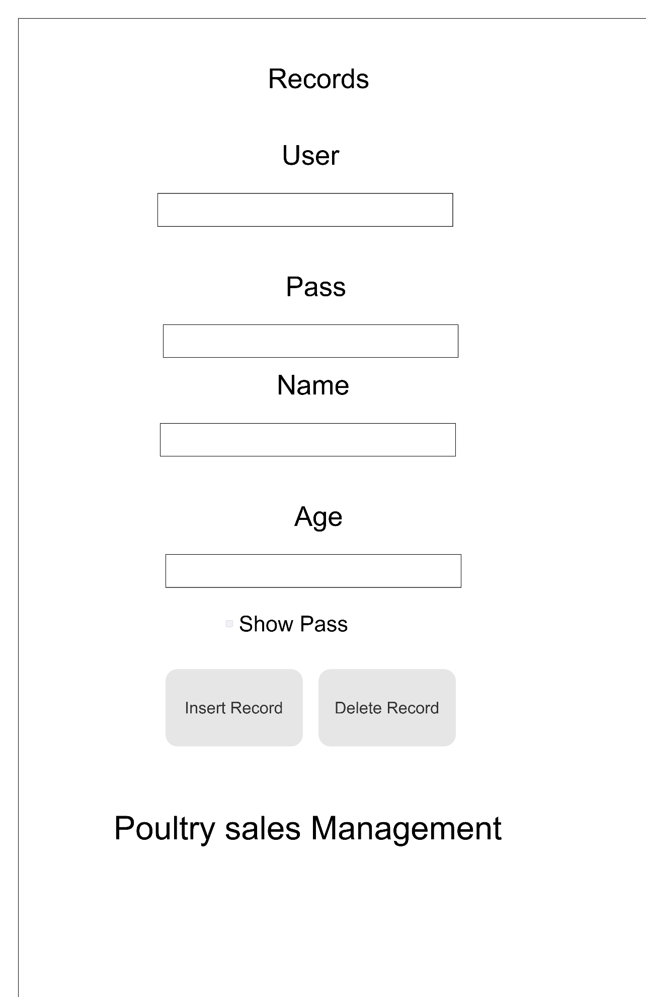

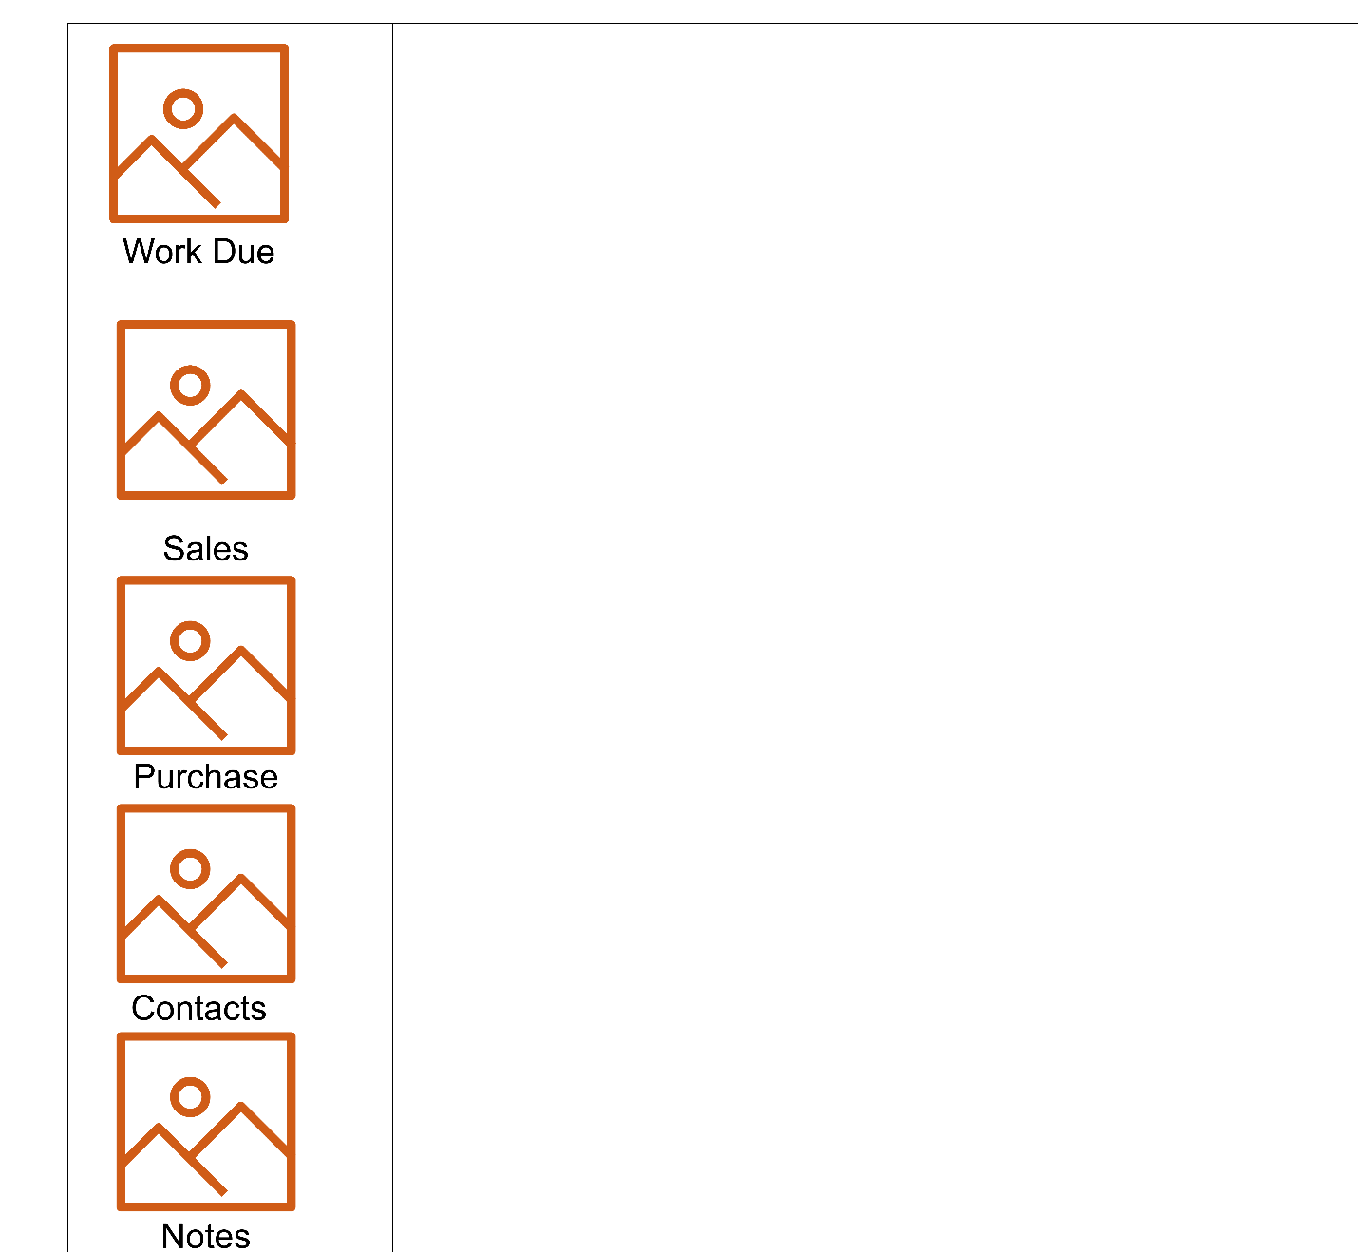

Sales:

The primary reason for this application is to help Poultry entrepreneur to keep refreshed with their sales. In this way, it has an alternative to stay aware of Product ID, Product Name, Product Price, and Product Quantity. It likewise has an alternative to Insert new insights regarding deals or erase old details.

# Data Storage:

There are two elements to this framework. One is of representative and the other is of the Owner. The proprietor needs to make a record for the worker so he/she can approach the framework. The worker can oversee assignments, can check buys, and can check deals in the framework. While the proprietor has every consent that an Employee has yet can likewise add clients to the framework so they can sign into the framework.

# Program Function:

Use Case Diagram:

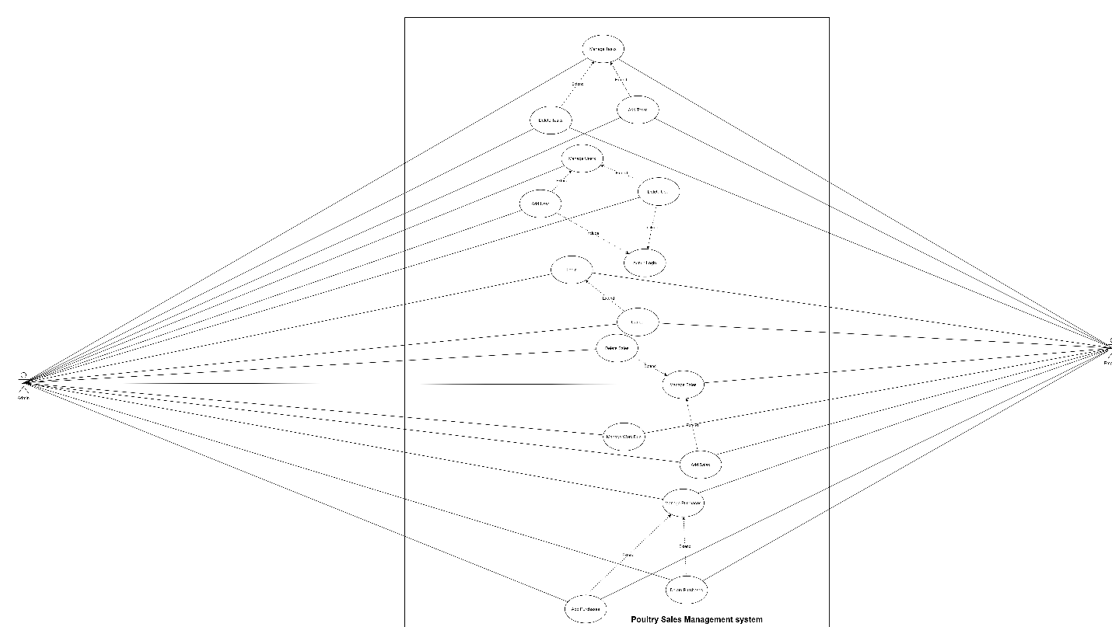

Class Diagram:

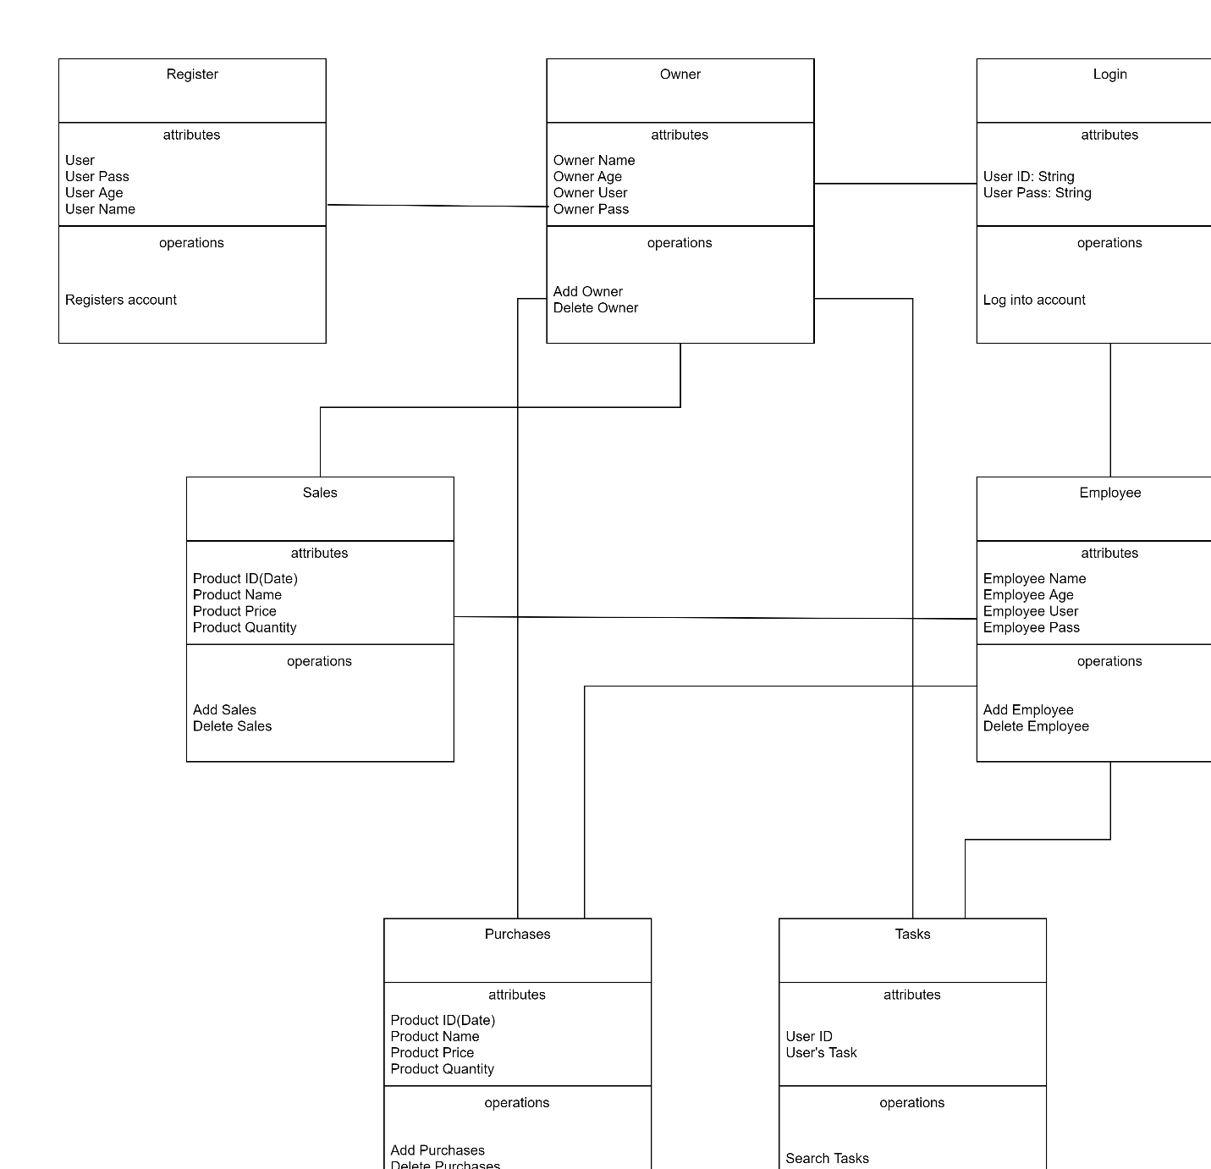

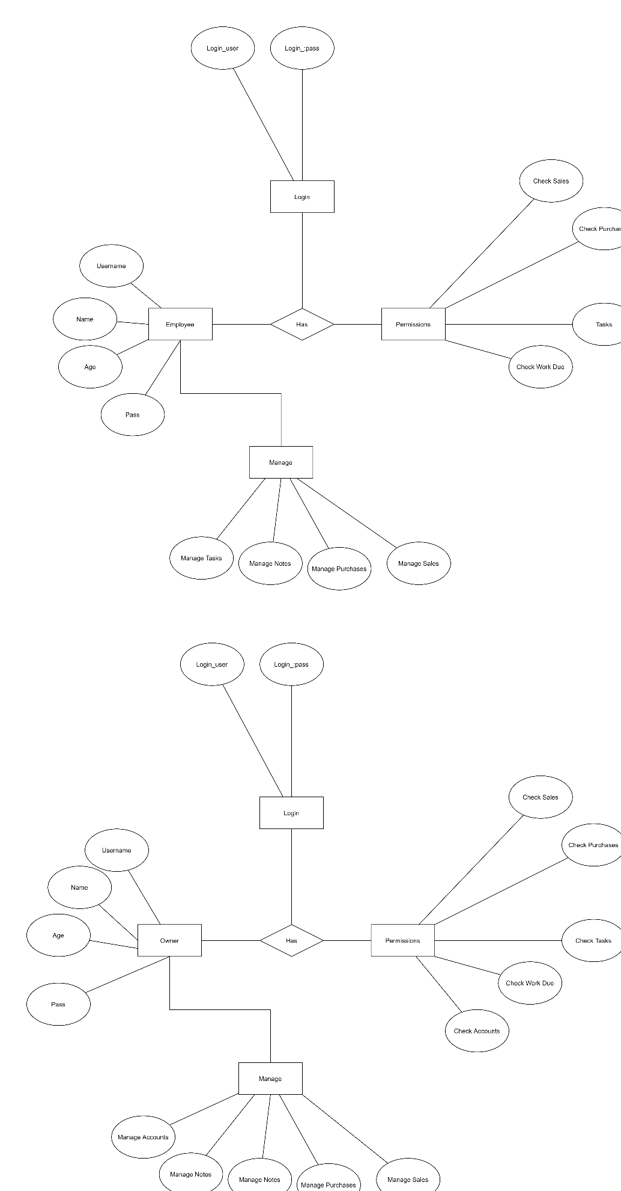

# Testing:

The need for the examination run of the framework assumes a powerful part to achieve the deformities that were made during the cycle. This improves the quality and it is essential in future. It insists that the framework has met the components that were requested. This permits us to have stress on the mix-ups that could be a blunder and stay concealed and that would cause an issue for the clients. This improves the tendency to address the issues viably. Allowing us to give a polished item eventually for its support.

Testing the code instructs how to compose great code since it permits fixing all terrible code. When fixing bugs we learn various approaches to tackle issues. The quantity of ways we can break code is boundless and that is the thing that makes it so intriguing. It additionally permits us to save time.

# Conclusion:

This application for the most part helps poultry organizations to beat their feverish spending on worker and to work more intelligent. This application doesn't have a superior quest choice for each tab. That will be added shortly. Changing the topic will affect the application enormously. In general, the environment will be easy to use after a few future upkeep alterations.